ITA0601 – MACHINE LEARNING
LAB EXPERIMENTS
EXP-9: Linear and Polynomial Regression using Python
Dataset 1 – House Size vs House Price
House Size (sq.ft) | Price (Lakhs)
500 | 25
700 | 32
900 | 40
1100 | 48
1300 | 60
1500 | 72
1700 | 88
1900 | 105
2100 | 125
2300 | 148
Python Code:
import numpy as np
import matplotlib.pyplot as plt
from sklearn.linear_model import LinearRegression
from sklearn.preprocessing import PolynomialFeatures
from sklearn.metrics import r2_score
X = np.array([500, 700, 900, 1100, 1300, 1500, 1700, 1900, 2100, 2300]).reshape(-1, 1)
y = np.array([25, 32, 40, 48, 60, 72, 88, 105, 125, 148])
linear_model = LinearRegression()
linear_model.fit(X, y)
linear_pred = linear_model.predict(X)
poly = PolynomialFeatures(degree=2)
X_poly = poly.fit_transform(X)
poly_model = LinearRegression()
poly_model.fit(X_poly, y)
poly_pred = poly_model.predict(X_poly)
linear_r2 = r2_score(y, linear_pred)
poly_r2 = r2_score(y, poly_pred)
print("Linear Regression R2 Score:", linear_r2)
print("Polynomial Regression R2 Score:", poly_r2)
if poly_r2 > linear_r2:
print("Polynomial Regression performs better.")
else:
print("Linear Regression performs better.")
plt.scatter(X, y, label="Actual Data")
plt.plot(X, linear_pred, label="Linear Regression")
plt.plot(X, poly_pred, label="Polynomial Regression")
plt.xlabel("House Size (sq.ft)")
plt.ylabel("Price (Lakhs)")
plt.title("House Size vs House Price")
plt.legend()
plt.show()
Output:
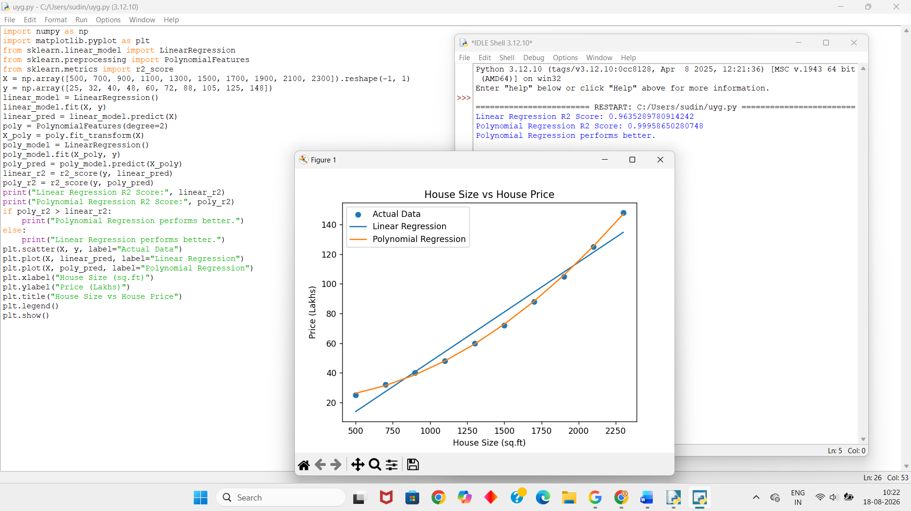

Dataset 2 – Years of Experience vs Salary
Experience (Years) | Salary (₹ Lakhs)
1 | 3.0
2 | 3.8
3 | 4.5
4 | 5.2
5 | 6.2
6 | 7.5
7 | 9.0
8 | 10.8
9 | 13.0
10 | 15.5
Python Code:
import numpy as np
import matplotlib.pyplot as plt
from sklearn.linear_model import LinearRegression
from sklearn.preprocessing import PolynomialFeatures
from sklearn.metrics import r2_score
X = np.array([1, 2, 3, 4, 5, 6, 7, 8, 9, 10]).reshape(-1, 1)
y = np.array([3.0, 3.8, 4.5, 5.2, 6.2, 7.5, 9.0, 10.8, 13.0, 15.5])
linear_model = LinearRegression()
linear_model.fit(X, y)
linear_pred = linear_model.predict(X)
poly = PolynomialFeatures(degree=2)
X_poly = poly.fit_transform(X)
poly_model = LinearRegression()
poly_model.fit(X_poly, y)
poly_pred = poly_model.predict(X_poly)
linear_r2 = r2_score(y, linear_pred)
poly_r2 = r2_score(y, poly_pred)
print("Linear Regression R2 Score:", linear_r2)
print("Polynomial Regression R2 Score:", poly_r2)
if poly_r2 > linear_r2:
print("Polynomial Regression performs better.")
else:
print("Linear Regression performs better.")
plt.scatter(X, y, label="Actual Data")
plt.plot(X, linear_pred, label="Linear Regression")
plt.plot(X, poly_pred, label="Polynomial Regression")
plt.xlabel("Experience (Years)")
plt.ylabel("Salary (Lakhs)")
plt.title("Experience vs Salary")
plt.legend()
plt.show()
Output:
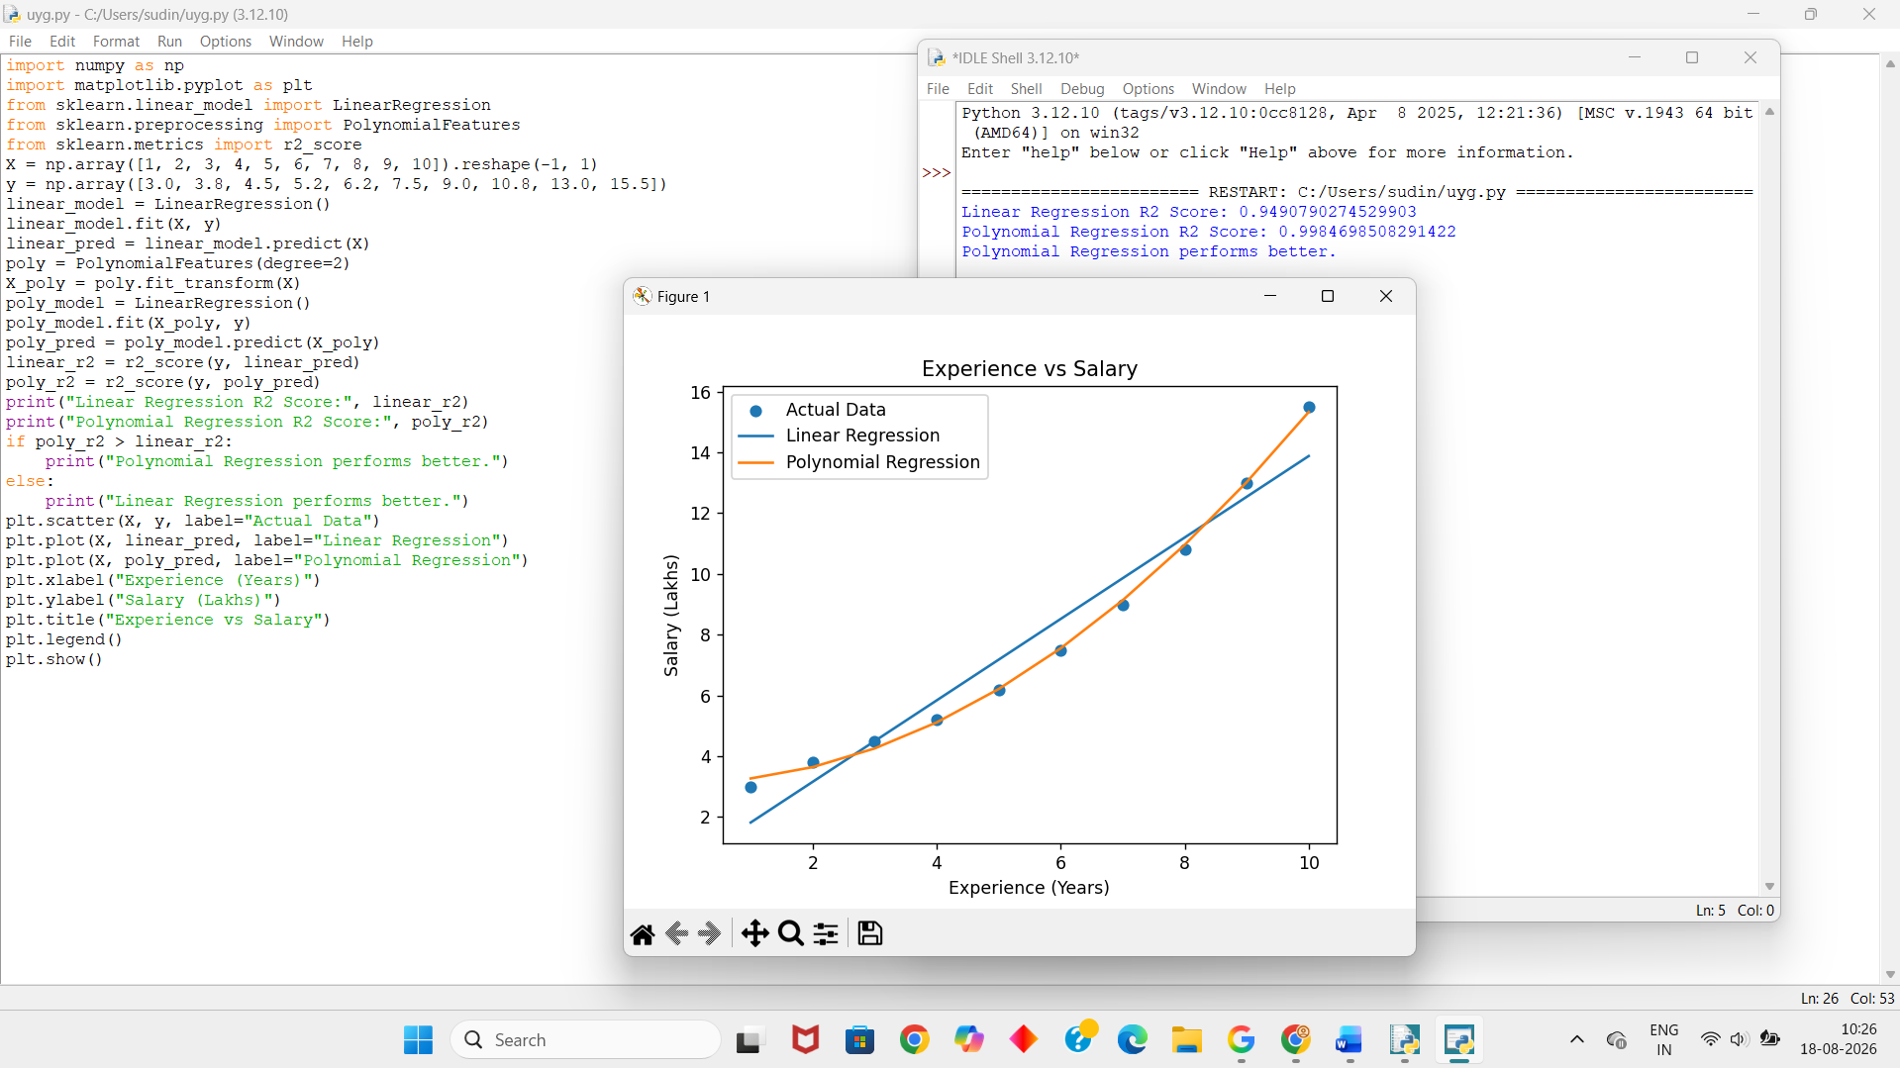
Dataset 3 – Temperature vs Ice Cream Sales
Temperature (°C) | Ice Cream Sales
15 | 120
18 | 150
20 | 190
22 | 240
24 | 300
26 | 370
28 | 450
30 | 540
32 | 640
34 | 750
Python Code:
import numpy as np
import matplotlib.pyplot as plt
from sklearn.linear_model import LinearRegression
from sklearn.preprocessing import PolynomialFeatures
from sklearn.metrics import r2_score
X = np.array([15, 18, 20, 22, 24, 26, 28, 30, 32, 34]).reshape(-1, 1)
y = np.array([120, 150, 190, 240, 300, 370, 450, 540, 640, 750])
linear_model = LinearRegression()
linear_model.fit(X, y)
linear_pred = linear_model.predict(X)
poly = PolynomialFeatures(degree=2)
X_poly = poly.fit_transform(X)
poly_model = LinearRegression()
poly_model.fit(X_poly, y)
poly_pred = poly_model.predict(X_poly)
linear_r2 = r2_score(y, linear_pred)
poly_r2 = r2_score(y, poly_pred)
print("Linear Regression R2 Score:", linear_r2)
print("Polynomial Regression R2 Score:", poly_r2)
if poly_r2 > linear_r2:
print("Polynomial Regression performs better.")
else:
print("Linear Regression performs better.")
plt.scatter(X, y, label="Actual Data")
plt.plot(X, linear_pred, label="Linear Regression")
plt.plot(X, poly_pred, label="Polynomial Regression")
plt.xlabel("Temperature (°C)")
plt.ylabel("Ice Cream Sales")
plt.title("Temperature vs Ice Cream Sales")
plt.legend()
plt.show()
Output:
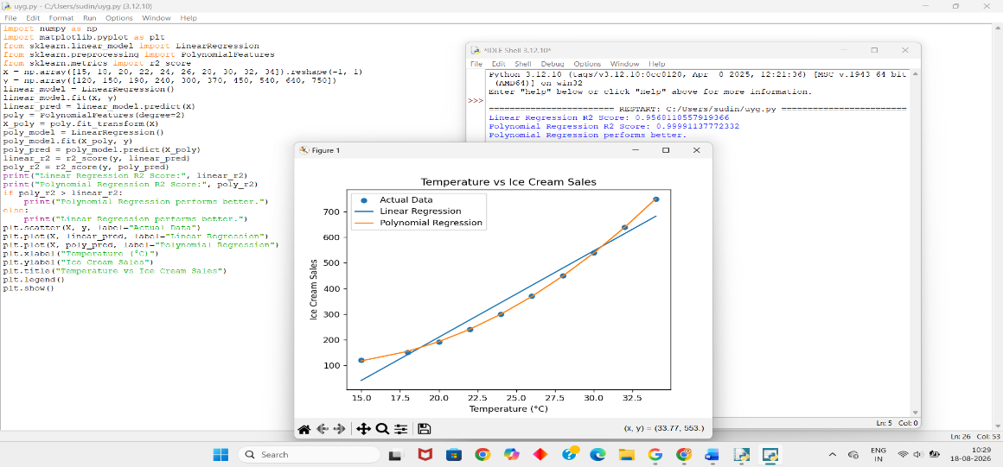
Dataset 4 – Advertising Cost vs Sales
Advertising Cost (₹ Thousand) | Sales (Units)
10 | 120
20 | 190
30 | 250
40 | 300
50 | 340
60 | 370
70 | 395
80 | 410
90 | 420
100 | 425
Python Code:
import numpy as np
import matplotlib.pyplot as plt
from sklearn.linear_model import LinearRegression
from sklearn.preprocessing import PolynomialFeatures
from sklearn.metrics import r2_score
X = np.array([10, 20, 30, 40, 50, 60, 70, 80, 90, 100]).reshape(-1, 1)
y = np.array([120, 190, 250, 300, 340, 370, 395, 410, 420, 425])
linear_model = LinearRegression()
linear_model.fit(X, y)
linear_pred = linear_model.predict(X)
poly = PolynomialFeatures(degree=2)
X_poly = poly.fit_transform(X)
poly_model = LinearRegression()
poly_model.fit(X_poly, y)
poly_pred = poly_model.predict(X_poly)
linear_r2 = r2_score(y, linear_pred)
poly_r2 = r2_score(y, poly_pred)
print("Linear Regression R2 Score:", linear_r2)
print("Polynomial Regression R2 Score:", poly_r2)
if poly_r2 > linear_r2:
print("Polynomial Regression performs better.")
else:
print("Linear Regression performs better.")
plt.scatter(X, y, label="Actual Data")
plt.plot(X, linear_pred, label="Linear Regression")
plt.plot(X, poly_pred, label="Polynomial Regression")
plt.xlabel("Advertising Cost (₹ Thousand)")
plt.ylabel("Sales")
plt.title("Advertising Cost vs Sales")
plt.legend()
plt.show()
Output:
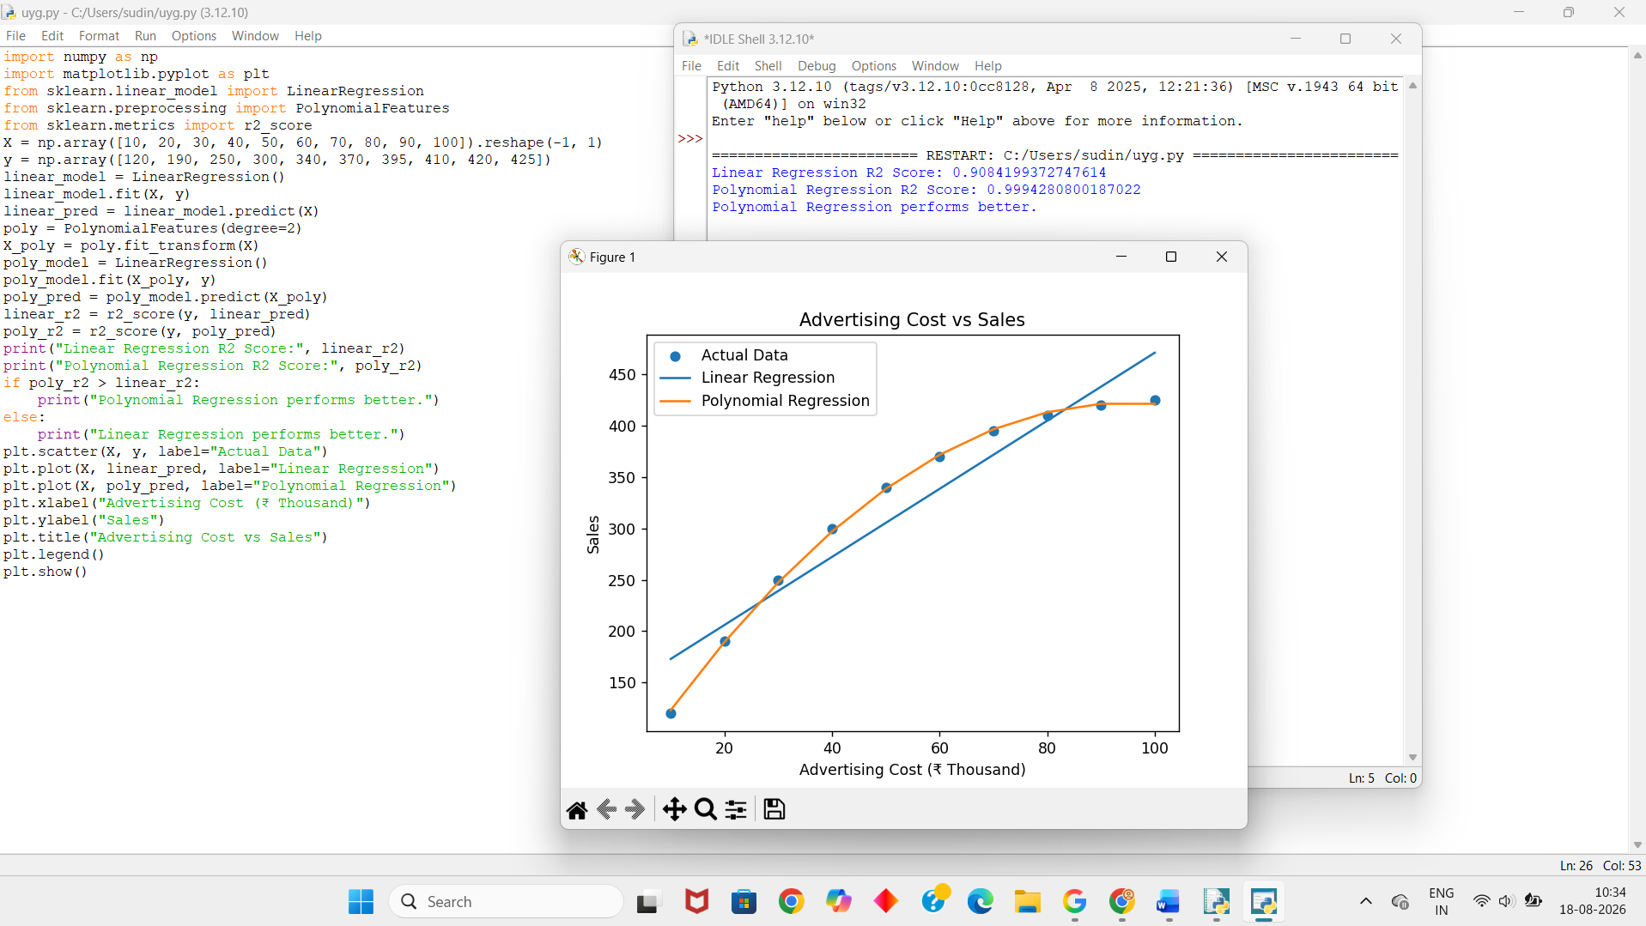
Dataset 5 – Study Hours vs Exam Marks
Study Hours | Marks
1 | 35
2 | 42
3 | 50
4 | 57
5 | 65
6 | 72
7 | 78
8 | 83
9 | 87
10 | 90
Python Code:
import numpy as np
import matplotlib.pyplot as plt
from sklearn.linear_model import LinearRegression
from sklearn.preprocessing import PolynomialFeatures
from sklearn.metrics import r2_score
X = np.array([1, 2, 3, 4, 5, 6, 7, 8, 9, 10]).reshape(-1, 1)
y = np.array([35, 42, 50, 57, 65, 72, 78, 83, 87, 90])
linear_model = LinearRegression()
linear_model.fit(X, y)
linear_pred = linear_model.predict(X)
poly = PolynomialFeatures(degree=2)
X_poly = poly.fit_transform(X)
poly_model = LinearRegression()
poly_model.fit(X_poly, y)
poly_pred = poly_model.predict(X_poly)
linear_r2 = r2_score(y, linear_pred)
poly_r2 = r2_score(y, poly_pred)
print("Linear Regression R2 Score:", linear_r2)
print("Polynomial Regression R2 Score:", poly_r2)
if poly_r2 > linear_r2:
print("Polynomial Regression performs better.")
else:
print("Linear Regression performs better.")
plt.scatter(X, y, label="Actual Data")
plt.plot(X, linear_pred, label="Linear Regression")
plt.plot(X, poly_pred, label="Polynomial Regression")
plt.xlabel("Study Hours")
plt.ylabel("Exam Marks")
plt.title("Study Hours vs Exam Marks")
plt.legend()
plt.show()
Output:
